He Rauemi Aromatawai ā-Roto - KUA MŌNEHU
Paerewa Paetae Pāngarau 91032: Te whakamahi tikanga tapatoru hāngai hei whakaoti rapanga ine
Te Kaupapa Ako: Pāngarau 1.7A v1
Te Ingoa o te Rauemi: Ngā Pou Whutupōro
Whiwhinga: 3
Tohutohu mā te Ākonga
Te Horopaki
Kua mutu te wāhanga o te tau mō te tākaro whutupōro, ā, kei te whakaritea kia whakahokia ngā pou whutupōro ki te hēti (wharau rānei), ki reira noho ai mō te raumati. Ka kawea ake ngā pou mā runga i tētahi wakatō.
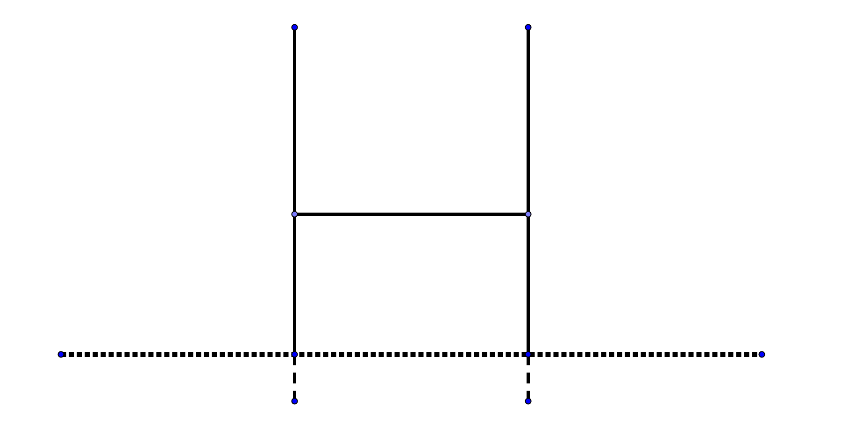

Hei Mahi
He poutū ngā pou whutupōro, 0.5m te hōhonu ki roto i te whenua. E 5.6m te roa o te te kaho (te wāhanga huapae o ngā pou whutupōro).
Ka mahi tahi kōrua ko tētahi atu ki te whiriwhiri i te teitei o ngā pou i runga ake i te whenua. Kia rua ngā tikanga hei whiriwhiri i te teitei: mā te whakamahi i ngā ātārangi o ngā pou, mā kōrua anō e whakaaro tētahi atu tikanga.
He tapawhā hāngai te papa o te wakatō, e 6m te roa, e 2.5m te whānui. Ko te 0.5m te teitei o ngā taha o te wakatō. Ina whakatakotoria ngā pou ki te hauroki o te wakatō, tērā tonu pea ka puta ki waho atu o te wakatō pēnei i te hoahoa nei:

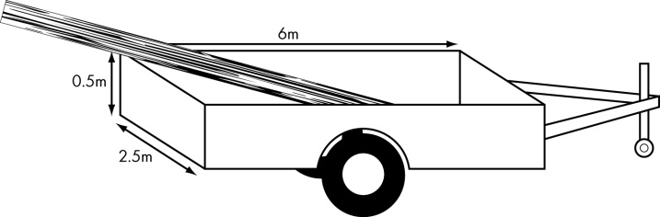

Kia haumaru ai te kawenga o ngā pou, e tika ana kia kaua e nui ake i te 1m te toronga huapae o ngā pou ki waho atu i te wakatō. E taea ana ngā taha o te wakatō te hiki kia teitei ake. Māu anō e whiriwhiri te teitei o ngā taha o te wakatō, kia kaua e roa ake i te 1m te toronga huapae o ngā pou i waho atu o te wakatō.

Wā Mahi 1
Ka mahi tahi kōrua ko tētahi atu ākonga i tēnei wā mahi.
- Āta whakaarohia ētahi tikanga e rua hei whiriwhiri i te teitei o ngā pou whutupōro o tō kura. Ko tētahi o aua tikanga, ko te whakamahi i te ātārangi o ngā pou.
- Ka mahi tahi kōrua ki te whakatutuki i ngā inenga e hiahiatia ana mō ngā tikanga e rua kua whakaarohia e kōrua.

Wā Mahi 2
Ka mahi koe i tōu kotahi i tēnei wā mahi.
Whakamahia ngā inenga i oti ai i te wā mahi tuatahi hei whiriwhiri i ēnei:
Te teitei o ngā pou whutupōro o tō kura. Whakaaturia ngā tikanga e rua i whakaarohia e kōrua ko tō hoa i te wā mahi tuatahi, me ngā whiriwhiringa mō ia tikanga.
Mehemea e taea ana ngā pou te kawe mā runga i te wakatō, kāore rānei (me te mau tonu ki ngā tikanga haumaru).
Te teitei o ngā taha o te wakatō, kia kaua e roa ake i te 1m te toronga huapae o ngā pou i waho atu i te wakatō
Mā te kounga o ō whakaaro whaitake, mā te whānui o ngā tikanga pāngarau ka whakamahia e koe, mā te tūhono anō i ngā otinga ki te horopaki o te rapanga, e tohua ai te taumata ka riro i a koe mō tēnei aromatawai.
Kia whaitake te whakaawhiwhi i āu tātaitanga, me whakaatu hoki i ngā waeine.
Kia mārama āu kōrero mō ngā tikanga pāngarau ka whakamahia e koe, kia hāngai hoki ngā kīanga pāngarau, kia māmā anō te whai i te raupapatanga o āu tātaitanga.

Taunakitanga: Pāngarau 91032 Ngā Pou Whutupōro
Taunakitanga mō te Paetae | Taunakitanga mō te Kaiaka | Taunakitanga mō te Kairangi
E tutuki ai te taumata o te paetae, me whakatutuki ngā inenga e hiahiatia ana, me whakamahi hoki ngā tikanga tapatoru hāngai hei whakaoti i ētahi wāhanga o tēnei ngohe. Arā:  - te whiriwhiri me te whakamahi i ētahi tikanga whānui;  - te whakaatu mōhiotanga ki ngā huatau ine, āhuahanga hoki, me ngā kupu e hāngai ana;  - te whakamārama i ngā otinga mēnā kotahi e rua rānei ngā mahi o roto i te tikanga i whakamahia ai.  Kia toru, nui ake rānei ngā tikanga hei whakamahi mā te ākonga, hei whakaoti i ētahi wāhanga o tēnei ngohe aromatawai.  He pai noa iho ngā hapa iti me ngā taurangitanga ka hua mai i ngā whakaawhiwhinga.  Kaua te ākonga e raru mēnā ka whakamahia te otinga hē o tētahi tātaitanga i roto i ngā tātaitanga o muri ake.  Hei tauira o ngā ‘tikanga whānui’ e hāngai ana ki tēnei ngohe:  Ko te whakatutuki inenga ā-ringa ki te tōtika e hāngai ana ki te horopaki o te rapanga  Te tikanga pākoki  Te teitei o ngā pou ki runga ake i te ine-rōnaki  = 30 x tan12 = 6.4m  Te tikanga tapatoru rite  Te teitei o ngā pou  = 16 x = 8m  Te ture a Pythagoras  Te hauroki o te papa o te wakatō = √(6² + 2.5²) = 6.5m  Te hauroki o te wakatō = √(6.5² + 0.5²) = 6.52m | E tutuki ai te taumata o te kaiaka, ka whakamahi tikanga tapatoru hāngai te ākonga hei whakaoti i tēnei ngohe ine, me te whai wāhi mai o te whakaaro tūhonohono. Arā:  - te whiriwhiri me te whakatutuki i te raupapatanga mahi arorau e hāngai ana;  - te tūhono i ētahi huatau rerekē, i ētahi whakaahuahanga rerekē rānei;  - te whakaatu māramatanga ki ngā huatau e hāngai ana;  - te hanga me te whakamahi tauira;  me te tūhono i ngā otinga ki te horopaki, te whakamahi rānei i ngā kīanga pāngarau e hāngai ana hei whakawhitiwhiti whakaaro.  He pai noa iho ngā hapa iti (pērā i te kore aro ki te 0.5m o ngā pou ki roto i te whenua), ngā taurangitanga ka hua mai i ngā whakaawhiwhinga, me te paku rehurehu pea o ngā whakamārama.  Kia tika ngā waeine, me te tūhono anō i ngā otinga ki te horopaki o te rapanga.  Hei tauira o ngā tātaitanga hei whakaatu i te iti ake o te hauroki o te wakatō i te roa o ngā pou  Te tikanga pākoki  Te teitei o ngā pou ki runga ake i te ine-rōnaki  = 30 x tan12 = 6.4m  Nō reira, ko te teitei o ngā pou (i runga ake i te whenua) = 6.4 + 1.7 m = 8.1m  Te tikanga tapatoru rite  Te teitei o ngā pou  = 16 x = 8m  Ka whakaawhiwhia te teitei o ngā pou ki te 8m  Nō reira, ko te roa o ngā pou hei kawe i roto i te wakatō = 8 + 0.5 = 8.5m  Te ture a Pythagoras  Te hauroki o te papa o te wakatō  = √(6² + 2.5²) = 6.5m  Nō reira ko te hauroki o te wakatō  = √(6.5² + 0.5²) = 6.52m  Nō reira, he roa rawa ngā pou hei kawe i roto i te wakatō kia kaua e roa ake i te 1m te toronga huapae i waho atu i te wakatō. | E tutuki ai te taumata o te kairangi, ka whakamahi tikanga tapatoru hāngai te ākonga hei whakaoti i tēnei ngohe, me te whai wāhi mai o te whakaaro waitara whānui. Arā:  - te hanga rautaki hei tūhura, hei whakaoti i tēnei ngohe;  - te tautohu i ngā huatau e hāngai ana ki te horopaki;  - te whakaputa i tētahi raupapatanga whakaaro arorau, i tētahi hāponotanga rānei;  - te hanga whakawhānuitanga;  me te whakamahi kīanga pāngarau tika, te whakawhitiwhiti rānei i te aroā pāngarau.  Kia tika te whakaoti i ngā wāhanga e rua o te rapanga, me te whakamahi anō i ngā kīanga pāngarau tika hei whakamārama i ngā otinga.  He pai noa iho ngā hapa iti ka puta i ngā whakaawhiwhinga.  Kia tika ngā waeine, me te tūhono anō i ngā otinga ki te horopaki o te rapanga.  Kaua te ākonga e raru mēnā ka whakamahia e ia te otinga hē o tētahi tātaitanga i roto i ngā tātaitanga o muri ake.  Hei tauira:  - Ngā tātaitanga hei whakaatu i te iti ake o te hauroki o te wakatō i te roa o ngā pou;  - ME ngā tātaitanga hei whakaatu i ngā inenga tapa o te wakatō e haumaru ai te kawe i ngā pou (kia kaua e nui ake i te 1m te toronga huapae o ngā pou i waho atu o te wakatō);  - ME ngā whakamārama pāngarau e hāngai ana.  Tikanga 1  Te teitei o ngā pou ki runga ake i te ine-koki  = 30 x tan12 = 6.4m (tikanga pākoki)  Nō reira ko te teitei o ngā pou (ki runga ake i te whenua) = 6.4 + 1.7 m = 8.1m  Tikanga 2  Te teitei o ngā pou  = 16 x = 8m (tapatoru he ōrite te āhua)  Ka whakaawhiwhia te teitei o ngā pou ki te 8m.  Nō reira, ko te roa o ngā pou hei kawe i roto i te wakatō = 8 + 0.5 = 8.5m  Tikanga 3  Te hauroki o te takere o te wakatō  = √(6² + 2.5²) = 6.5m (te ture o Pythagoras)  Nō reira, ko te hauroki o te wakatō  = √(6.5² + 0.5²) = 6.52m (te ture o Pythagoras)  He roa rawa ngā pou hei kawe i roto i te wakatō kia kaua e roa ake i te 1m te toronga huapae i waho atu i te wakatō.  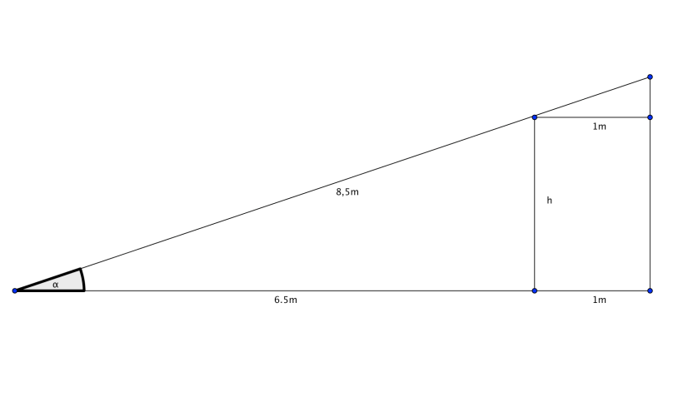  E whakaaturia ana te toronga huapae rahi rawa ki waho atu i te wakatō (1m) i te hoahoa nei. Ka whiriwhiria te h, te teitei o ngā taha o te wakatō.  cos α = 7.5/8.5  nō reira α = 28⁰  h = 6.5tanα = 3.46m  Nō reira, kia 3.46 te teitei o ngā taha o te wakatō, kia nui ake rānei.

